1. **THE DIGITAL WORLD & WORKING IN IT**

**PRACTICE!**

1. **Decide if the sentences below are true or false.**

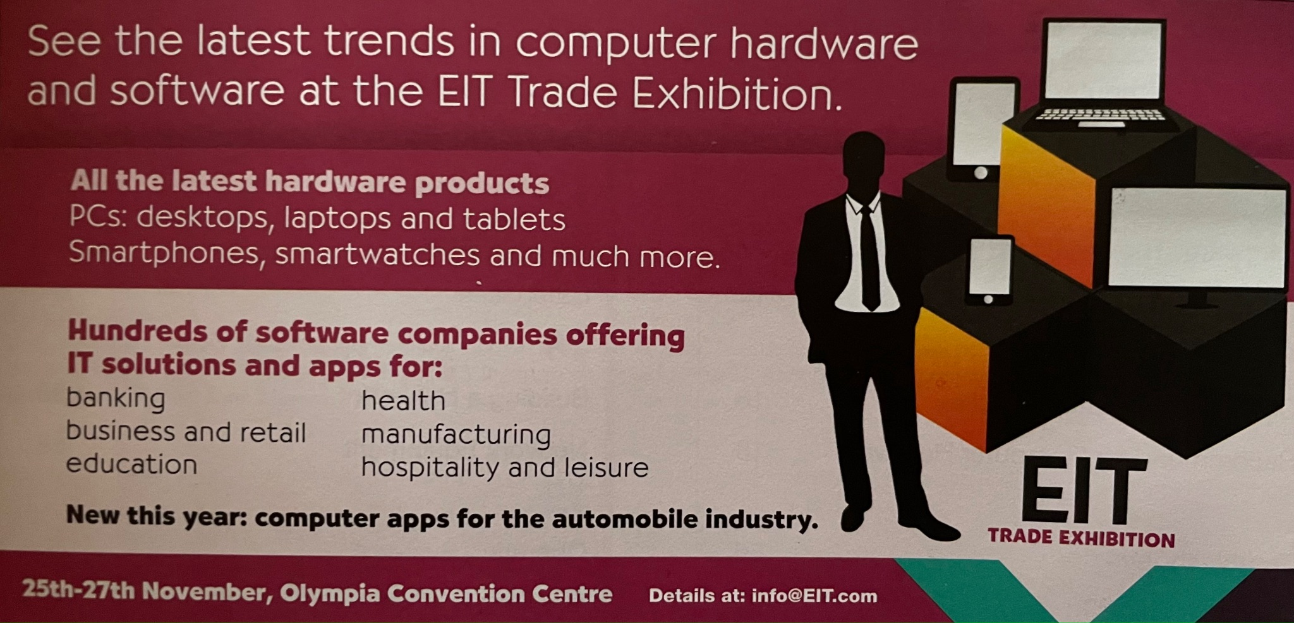

* The trade exhibition is only for computer hardware. __False__
* The products exhibited include different types of computers. __True__
* The exhibition is only for banking and businesses. __False__
* There are computer products for schools, hospitals and factories. __True__
* You will find examples of the newest equipment at the trade exhibition. __True__

1. **Three people are getting information at the trade exhibition information desk. Read the mini dialogues and order them.**

| **Dialog 1**  _1___ **-** Good morning. Can I help you?  _4___ **-** Thank you.  _2___ **-** Yes, I'm looking for the Banking Plus exhibit.  _3___ **-** That's exhibit number 2.218. |
| --- |
| **Dialog 2**  __3__ **-** I see it, thanks.  __1__ **-** Excuse me. Can you tell me where exhibit 345 is?  __2__ **-** Let me check. It's an exhibit of apps for the automobile industry. It's over there with the red sign. |
| **Dialog 3**  __3__ **-** You're welcome. Enjoy the exhibition.  __1__ **-** I'm interested in software for business.  __4__ **-** Thank you.  __2__ **-** Just a moment ... OK, you want exhibit numbers 107, 159 and 96. Here's a map to help you. |

1. **Read the profiles. Then copy and complete the sentences below with the correct name.**

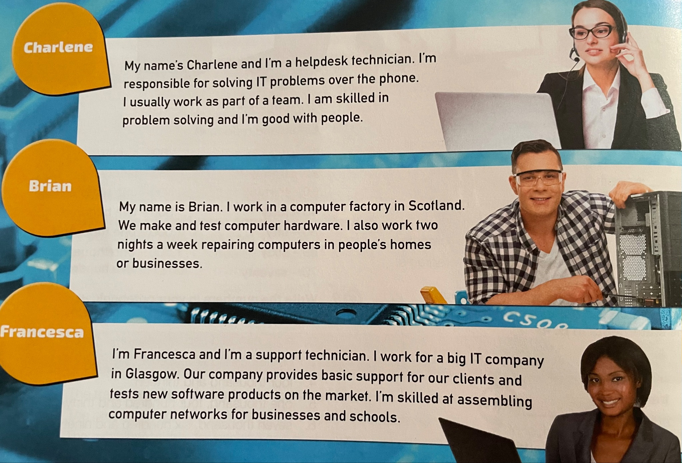

1. __Francesca________________ puts computer systems into businesses.

2. __Charlene________________ solves IT problems on the telephone.

3. __Brian________________ tests hardware.

4. __Brian________________ sometimes works at night.

5. __Brian________________ repairs computers.

6. __Charlene________________ works closely with a group of other people.